Sprint 2 -Agility Design Document

November 15, 2022

Table of Contents

1. Executive Summary 3

1.1 Project Overview 3

1.2 Purpose and Scope of this Specification 3

2. Product/Service Description 3

2.1 Product Context 3

2.2 User Characteristics 3

2.3 Assumptions 4

2.4 Constraints 4

2.5 Dependencies 4

3. Requirements 4

3.1 Functional Requirements 4

3.2 Security 4

3.2.1 Protection 4

3.2.2 Authorization and Authentication 4

3.3 Portability 5

4. Requirements Confirmation/Stakeholder sign-off 5

5. System Design 5

5.1 Algorithm 5

5.2 System Flow 6

5.3 Software 7

5.4 Hardware 7

5.5 Test Plan 8

5.6 Task List/Gantt Chart 9

5.7 Staffing Plan 9

# Executive Summary

## Project Overview

The robot will be made to traverse a taped track shaped like a figure-8 in Howard Hall room 208 five consecutive times. It will be made to follow the tape as closely as possible, and finish in a spot similar to where it began moving. After this, it will flash random colors for 5 seconds, before speaking the line “I am the winner!”. The robot will complete this task by executing the block code developed within the Sphero application.

## Purpose and Scope of this Specification

The Purpose of this project is for the robot to successfully travel along the blue tape on floor of room 208 in Howard Hall.

In scope

The following items are in scope:

* The robot will follow the taped figure-8 present in room HH-208 as closely as possible five consecutive times
* The robot will end up in the same place where it began following its traversal of the figure-eight tape-track.
* The robot will flash colors for at least five seconds after it is done moving
* The robot will speak the correct line in accordance with the instructions provided to each group

Out of Scope

The following items are out of scope:

* The robot will not accurately follow the figure-8 tape-track.
* The robot will end up in a place far from its initial starting position
* The robot will not flash colors correctly, or will not flash for a sufficient amount of time
* The robot will not speak the correct line at the correct time.

# Product/Service Description

* This Project is an assignment for *Intro to Problem Solving* (CS 104-01)
* Sprint #2 – Agility is due 11:59, November 15, 2022

## Product Context

* Sprint 2 (Agility) is independent
  + One part of a triathlon
* Connected to a larger project consisting of three parts but Sprint 2 is independent
* Sprint 1 is Endurance, Sprint 2 is Accuracy, Sprint 3 is Agility
* Three group members working collaboratively on all three parts of the project

## User Characteristics

1. Students taking the CS 104-01 course
   * Maximum of 2 or fewer years of computing experience
   * First time using / testing Sphero robot / block code
2. Professor of CS 104-01 course
   * Decades of computing experience
   * Is familiar with the Sphero robot application and the block code

## Assumptions

The robot is assumed to work and perform functions when it is programmed to do so. The block code is assumed to program the Sphero robot to perform as needed. All team members are assumed to be available at the same time to work cooperatively and collaboratively on all parts of the project. All team members are assumed to complete the individual work assigned to them per the Gantt chart. Howard Hall room 208 is assumed to be available when needed.

## Constraints

* Functionality / operation of the Sphero robot
* The blue tape on the ground
* Access to Howard Hall room 128
* Availability of all group members
* Sphero robot application

## Dependencies

* The process must take place in Howard Hall Room 128
* All team members must be available to work cooperatively and collaboratively
* The Sphero Application must be used to control the robot

# Requirements

## Functional Requirements

| Req# | Requirement | Comments | Priority | Date Reviewed | SME Reviewed / Approved |
| --- | --- | --- | --- | --- | --- |
| **AGLTY_01** | The robot will follow the figure-8 taped to the floor of Howard Hall room 208 as closely as possible and stop where it initially began. | This is the main portion of the project. Subsequently, it is the most important to get correct. | 1 | 11/13/22 | Approved by Sean Fritz |
| **AGLTY_02** | The robot will flash several different colors for at least 5 seconds. | This is what occurs immediately after step one (detailed above). | 2 | 11/13/22 | Approved by Sean Fritz |
| **AGLTY_03** | The robot will speak “I am the winner!” before terminating the program | This is the final portion of the program. It is a small part of the sprint, but still very important regardless | 3 | 11/13/22 | Approved by Sean Fritz |

## Security

A password is necessary to gain access to the computer which contains the block code for the Sphero Robot.

### Protection

* GitHub account, username, and password to access the GitHub repository
* Account username and password for the Sphero.edu account
* Sphero robot kept in safety container when not in use
* Sphero robot frequently charged to perform block code
* Email account with Sphero that has been authenticated

### Authorization and Authentication

A Sphero account with an authenticated email address is necessary

## Portability

* Sphero block code is absolutely host dependent
* Access to the Sphero block code and control of the Sphero robot can be accessed by computer or any mobile device

# Requirements Confirmation/Stakeholder sign-off

Include documentation of the approval or confirmation of the requirements here. For example:

|  |  |  |
| --- | --- | --- |
| Meeting Date | Attendees (name and role) | Comments |
| 11/12/2022 | Sean Fritz | Initial Programming |
| 11/14/2022 | Sean Fritz | Fitting test code to classroom measurements |
| 11/15/2022 | Sean Fritz, Anthony Tucci, Manar Elkader | Final test, sensor data retrieval, taking video |

# System Design

## Algorithm

Develop and describe here the algorithm that will be used to provide the required performance of your software:  
  
//Initialization

1. Enable Stabilization
2. Aim the robot at 0 degrees
3. Set the robot speed to 62

//Main Body

1. Initiate a loop that executes the body of code within in 5 times
   1. Spin the robot 360 degrees for 7.7 seconds
   2. Spin the robot -360 degrees for 7.7 seconds
2. Stop the robot
3. Initiate a loop that executes the body of code within it 2 times
   1. Flash the main LED red
   2. Delay for 0.5 seconds
   3. Flash the main LED blue
   4. Delay for 0.5 seconds
   5. Flash the main LED green
   6. Delay for 0.5 seconds
   7. Flash the main LED orange
   8. Delay for 0.5 seconds
   9. Flash the main LED violet
   10. Delay for 0.5 seconds
4. Speak “I am the winner!” and wait
5. Terminate the program

## System Flow

Develop a flowchart (and show here) that accurately depicts how your software application will act to fulfill the algorithm

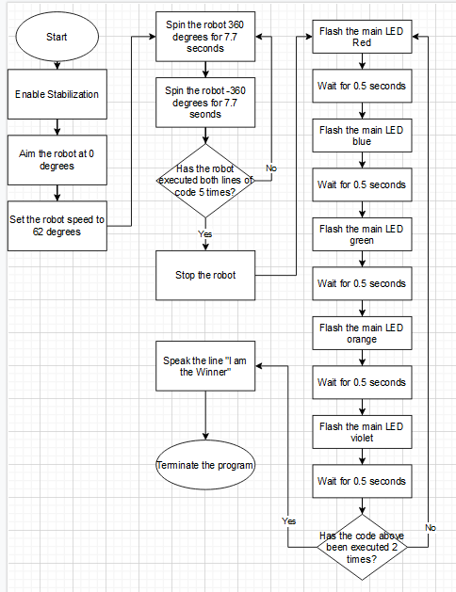

## Software

Describe software languages/platforms/APIs used to develop and deploy this application:

* The Sphero application is required to develop the block code necessary to allow the robot to perform functions. This application is available for download on most common operating systems (in terms of computers) and app stores (in terms of mobile devices). However, it *must* be done on an apple-developed operating system (Mac OS or iOS) in order to obtain the sensor data.
* Executable programs are developed using in-app block code (as pictured below) . This consists of function-templates with modifiable values.

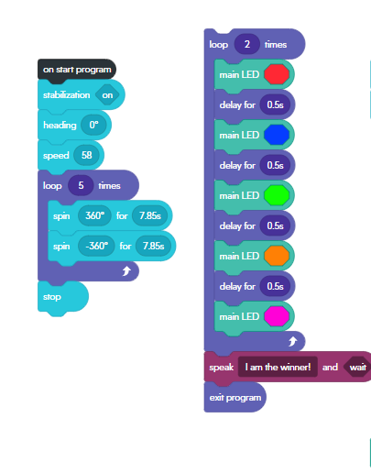 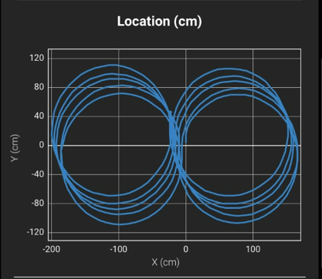

## Hardware

Several hardware platforms were used to develop, test, and demonstrate this application. These include:

* LG Laptop (Windows OS) – For development
* MacBook Pro (Mac OS) – For development
* iPhone (iOS) – For development and retrieval of sensor data
* Sphero Robot – For demonstrating program
* Bluetooth – Sphero robot executed code wirelessly

## Test Plan

| **Reason for Test Case** | **Test Date** | **Expected Output** | **Observed Output** | **Staff Name** | **Pass/Fail** |
| --- | --- | --- | --- | --- | --- |
| 1. Circular movement test no.1 | Nov. 12, 2022 | The robot should move in a circle | Robot moved at a curved 90 degree angle | Sean Fritz | Fail |
| 1. Circular movement test no.2 | Nov. 12, 2022 | The robot should move in a circle | Robot moves forward, then spins in circles in place | Sean Fritz | Fail |
| 1. Circular movement test no.3 | Nov. 12, 2022 | The robot should move in a circle | Robot moves in the shape of a small and uneven circle | Sean Fritz | Pass |
| 1. Consistency test no.1 | Nov 12, 2022 | The robot will navigate in a neater circle | Robot more obviously moves in a circular pattern | Sean Fritz | Pass |
| 1. Figure 8 test no. 1 | Nov 12, 2022 | The robot will move in the shape of a circle, then the shape of another circle in the opposite direction | Robot moves in the shape of the same circle twice (forgot to tweak a negative value) | Sean Fritz | Fail |
| 1. Figure 8 test no.2 | Nov 12, 2022 | The robot will move in the shape of a circle, then in the shape of another circle in the opposite direction | Robot moves in the shape of two separate, but conjoined circles, completing the figure 8 | Sean Fritz | Pass |
| 1. Figure 8 size adjustment test no.1 | Nov 14, 2022 | The robot will navigate a figure eight according to the measurements specified by the tape within the classroom | The robot navigates smaller circles than the track taped to the ground | Sean Fritz | Fail |
| 1. Figure 8 size adjustment test no.2 | Nov 14, 2022 | The robot will navigate a figure eight according to the measurements specified by the tape within the classroom | The robot traces a more consistent figure 8, in line with what is expected from us | Sean Fritz | Pass |
| 1. Figure 8 consistency test no.1 | Nov 14, 2022 | The robot will loop a figure-8 five times without a major malfunction | The robot strays from the path far too often to be ignored | Sean Fritz | Fail |
| 1. Figure 8 consistency test no.2 | Nov 14, 2022 | The robot will loop a figure-8 five times without a major malfunction | The robot completes the figure 8 five times at a sufficient consistency | Sean Fritz | Pass |
| 1. Final Test | Nov 15, 2022 | The robot will maneuver the figure eight path, strobe multiple colors, and speak the line “I am the winner!” before terminating | The robot works entirely as intended, without any major malfunctions or errors | Sean Fritz; Anthony Tucci; Manar Elkader | Pass |

## Task List/Gantt Chart

Embed your Gantt chart here:

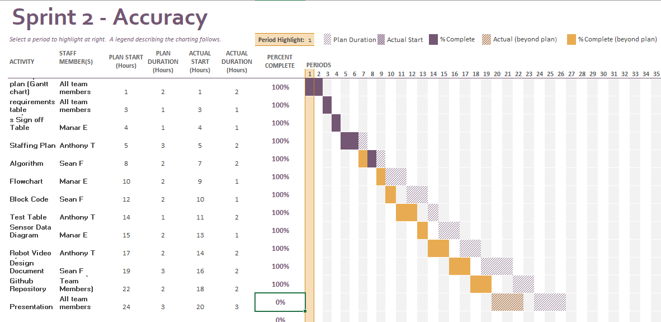

## Staffing Plan

Insert a chart/table that depicts the roles and responsibilities of each team member that worked on this project

| Name | Role | Responsibility | Reports To |
| --- | --- | --- | --- |
| Sean | Planner, Coordinator | Coder, Algorithm, flowchart | Anthony, Manar |
| Anthony | Organizer, tester | Test table, sensor data, staffing plan | Sean, Manar |
| Manar | Documenter, tester | Videographer, system design document | Sean, Anthony |